**Practical 13: AIM:** Demonstrate data driven Framework. **Theory:**

#### Data Driven Testing

**Data Driven Testing** is a software testing method in which test data is stored in table or spreadsheet format. Data driven testing allows testers to input a single test script that can execute tests for all test data from a table and expect the test output in the same table. It is also called table-driven testing or parameterized testing.

#### Data Driven Framework

**Data Driven Framework** is an automation testing framework in which input values are read from data files and stored into variables in test scripts. It enables testers to build both positive and negative test cases into a single test. Input data in data driven framework can be stored in single or multiple data sources like .xls, .xml, .csv and databases.

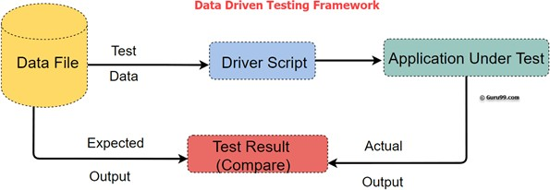

#### Code:

package pracs;

import org.openqa.selenium.By;

import org.openqa.selenium.WebDriver;

import org.openqa.selenium.firefox.FirefoxDriver; import org.testng.Assert;

import org.testng.annotations.AfterMethod; import org.testng.annotations.DataProvider; import org.testng.annotations.Test;

public class Thirteenth { WebDriver driver;

@Test(dataProvider="testdata")

public void demoClass(String username, String password) throws InterruptedException {

System.setProperty("webdriver.gecko.driver","geckodriver.exe"); driver = new FirefoxDriver();

driver.get("https://[www.phptravels.net/login](http://www.phptravels.net/login)"); driver.findElement(By.name("email")).sendKeys(username); driver.findElement(By.name("password")).sendKeys(password);

driver.findElement(By.xpath("/html/body/div[1]/div/div[2]/div[2]/div/form/ div[3]/button")).click();

Thread.sleep(5000); Assert.assertTrue(driver.getTitle().matches("Dashboard -

PHPTRAVELS"), "Invalid credentials"); System.out.println("Login successful");

}

@AfterMethod

void ProgramTermination() { driver.quit();

}

@DataProvider(name="testdata") public Object[][] testDataExample(){

ReadExcelFile configuration = new ReadExcelFile("F:\\STQA WORKSPACE\\stqa\\src\\pracs\\XYZ.xlsx");

int rows = configuration.getRowCount(0); Object[][]signin_credentials = new Object[rows][2];

for(int i=0;i<rows;i++)

{

signin_credentials[i][0] = configuration.getData(0, i, 0); signin_credentials[i][1] = configuration.getData(0, i, 1);

}

return signin_credentials;

}

}

#### Output:

Data in Excel sheet:

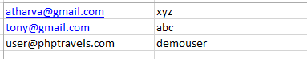

Wrong credentials

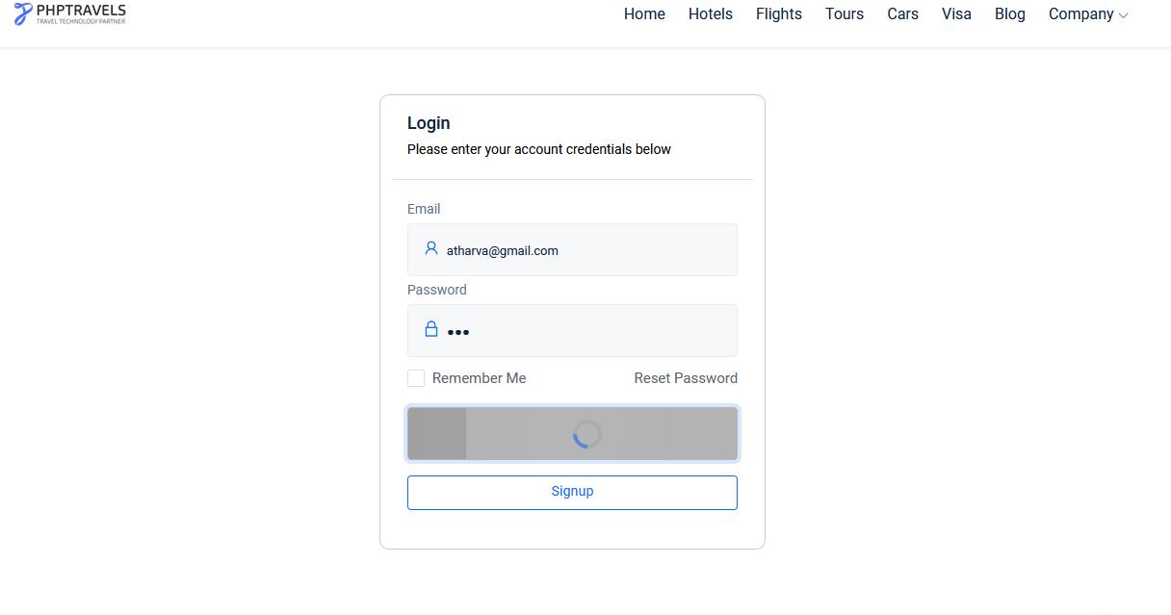

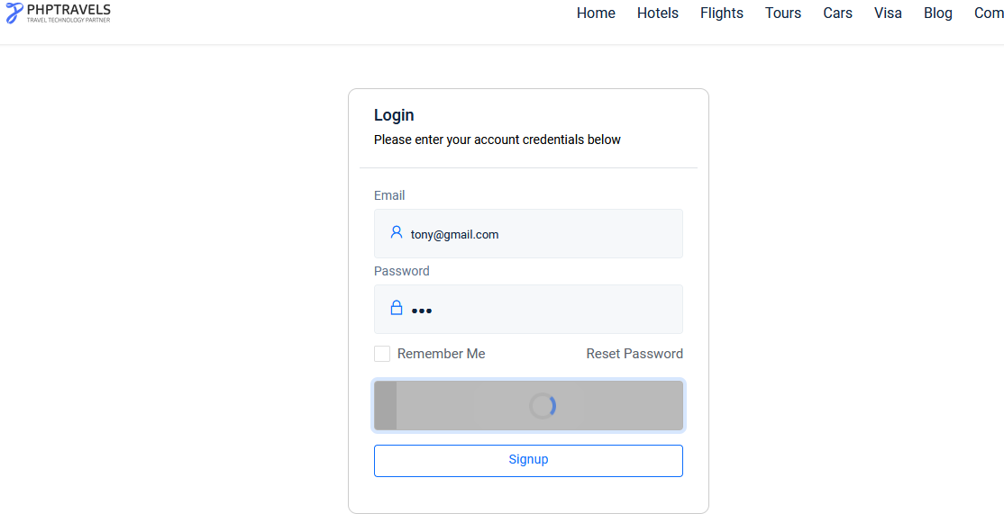

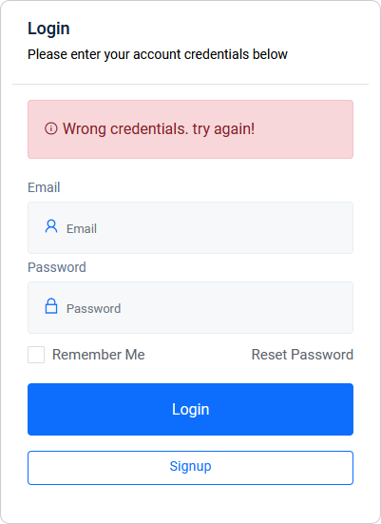

Correct credentials

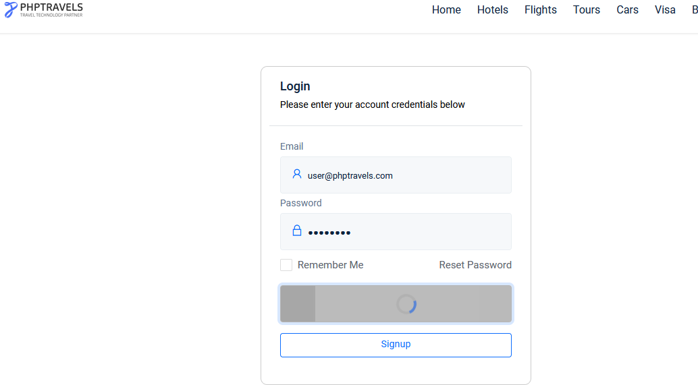

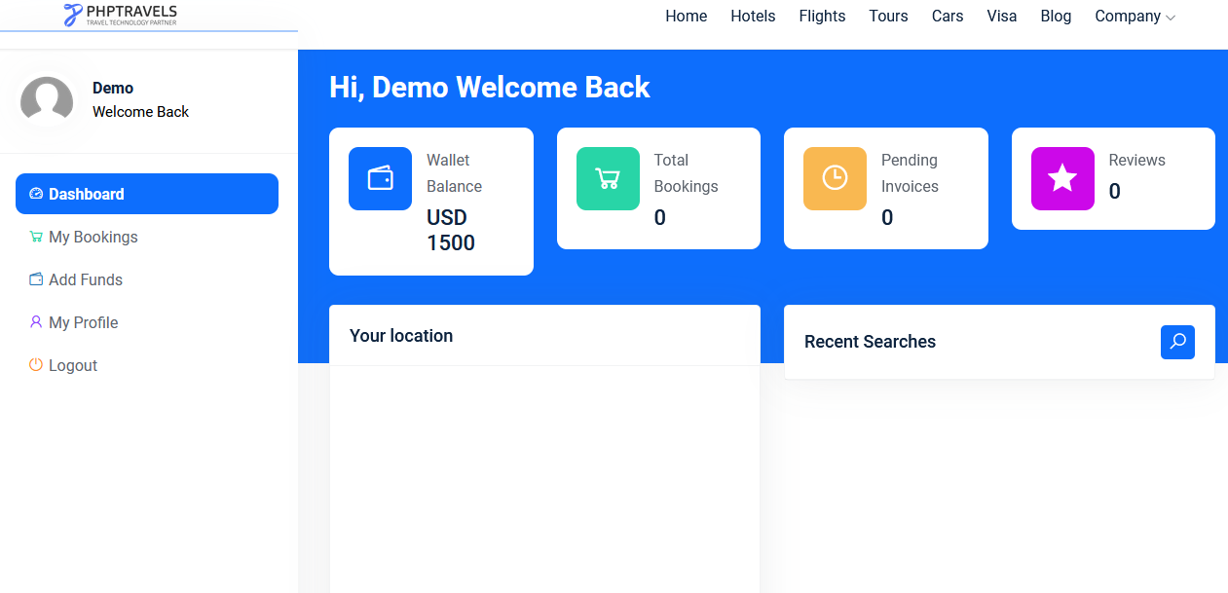

Console OP

